**Assignment 3**

**Q1:- Create a user named bob in Kali.**

Answer:-

**Add a User to Linux**

1.    Log in as **root**

2. Use the command**useradd** "name of the user" (for example,**useradd roman**)

3.    Use **su**plus the name of the user you just added to log on.

4.    "**Exit**" will log you out.

Here is another option for adding a user to a group in linux:

1.    Use the **usermod**command.

2.    Replace **examplegroup**with the name of the group.

3.    Replace **exampleusername**with the name of the user you want to add.

**Q2. Enable ssh on Kali**

### Answer:- Enable Kali Linux Remote SSH Service

First, you must remove the run levels by entering the following command.

*$*sudo update-rc.d -f ssh remove



The next step is to load SSH defaults.

*$*sudo update-rc.d -f ssh defaults



After loading, next, you will check whether the service is running.

*$*sudo chkconfig ssh



If you want to see a lot more, then you can install **chkconfig**, which can be installed by entering the following command code.

*$*sudo apt-get install chkconfig



You can run chkconfig by entering the command given below.

*$*sudo chkconfig -l ssh



(or)

*$*sudo chkconfig -l

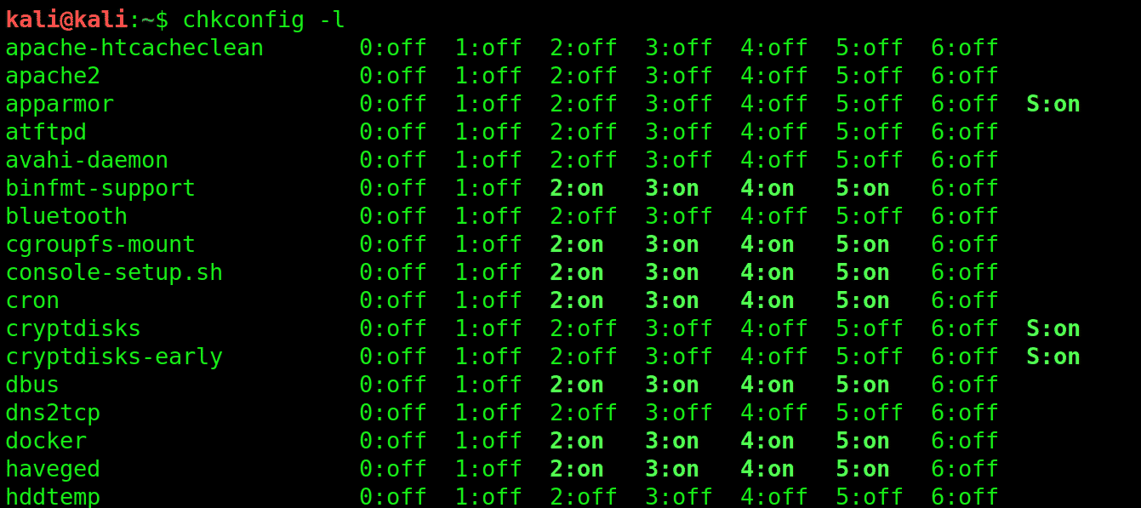

Q3. Allow bob to login into kali from git bash without a password using keys.

Answer:-

git config --global user.name myusername

git config --global user.email myemail

git config --global github.user myusername

git config --global github.token mytoken